New Captured Results (without wrappers):

Trial 2: ent_coef: 0.001

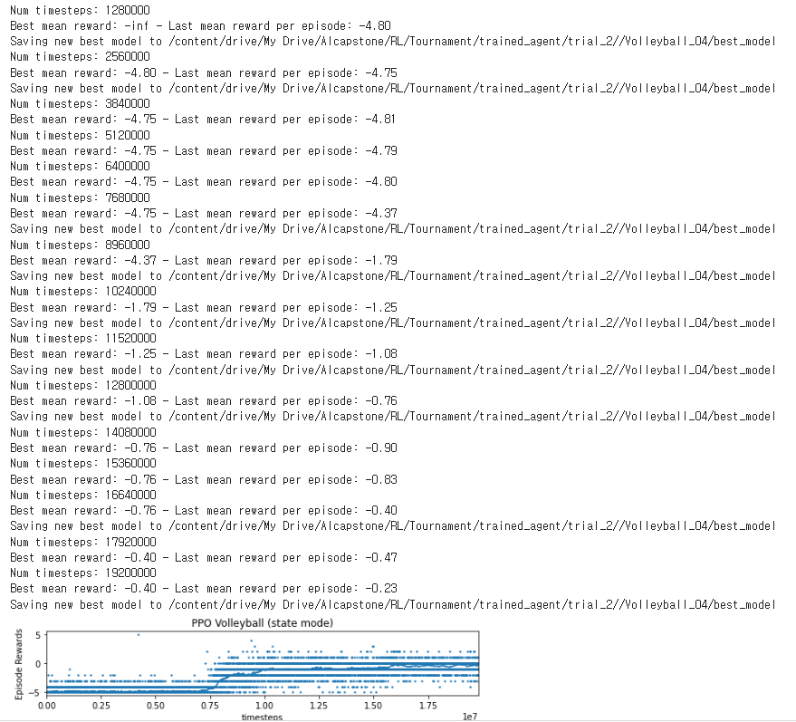

Trial 3 : ent_coef = 0.00001

더 낮음

Trial 4: learning rate = lin_0.00096

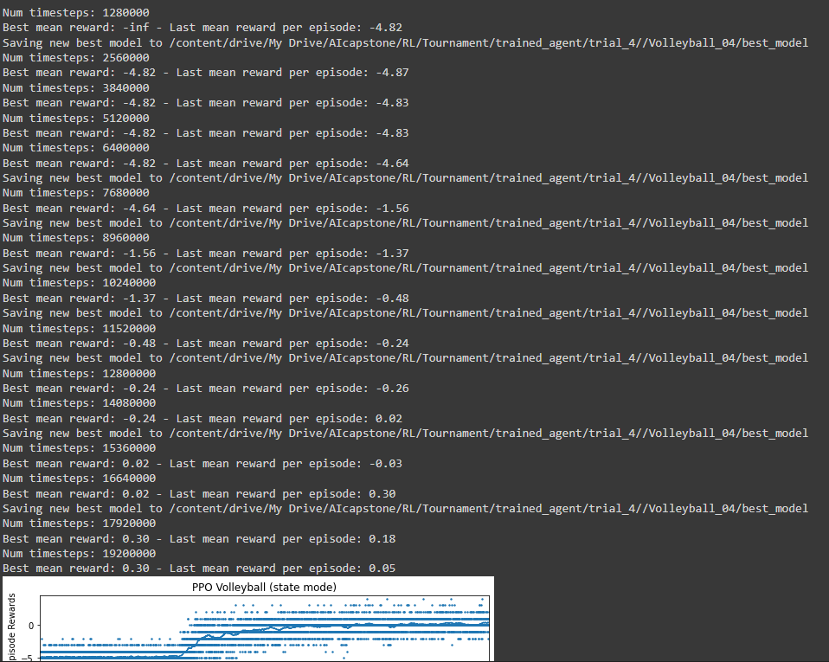

Trial 6: gae_lambda: 0.9

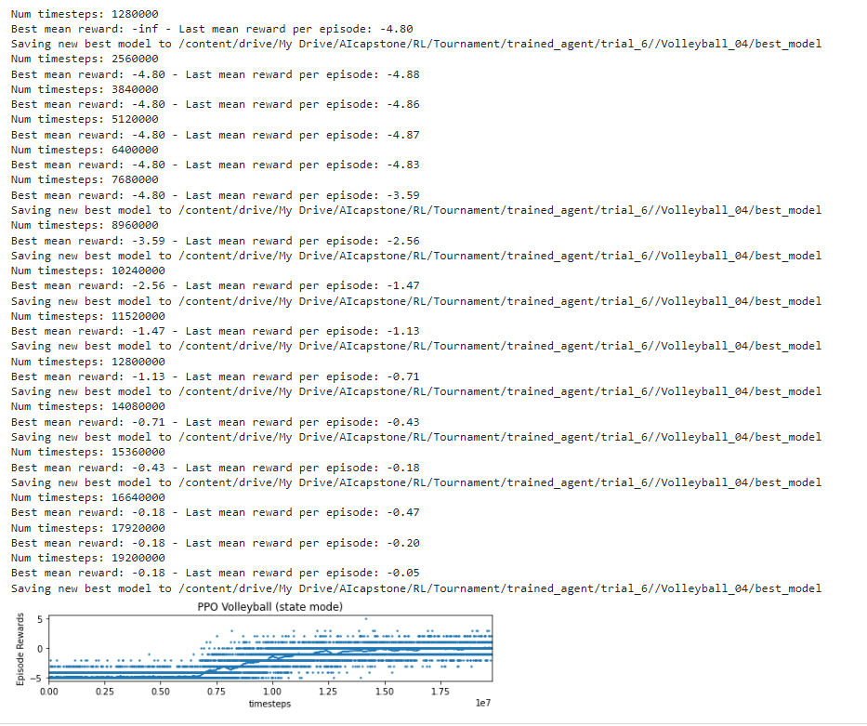

Trial 7: vf_coef = 0.4

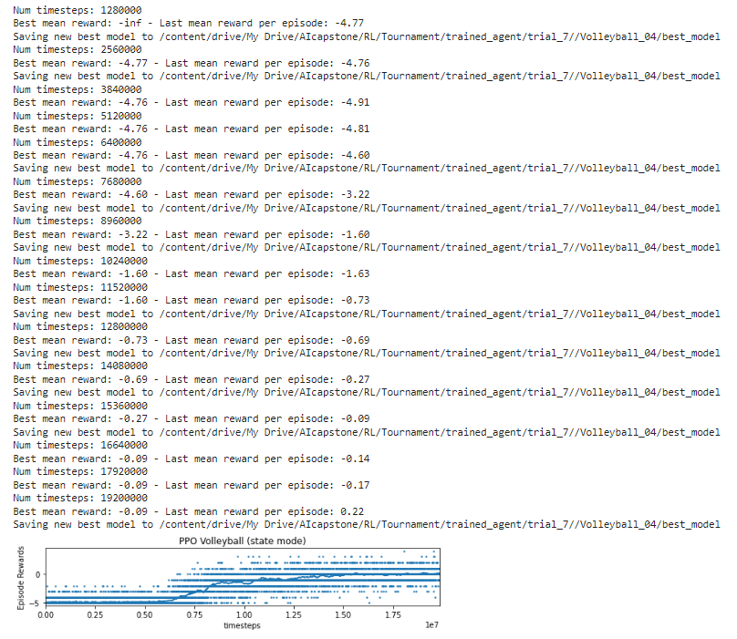

Trial 8: learning rate = lin(0.00012)

더 낮음

Old Captured Results (with wrappers):

Trial 1:

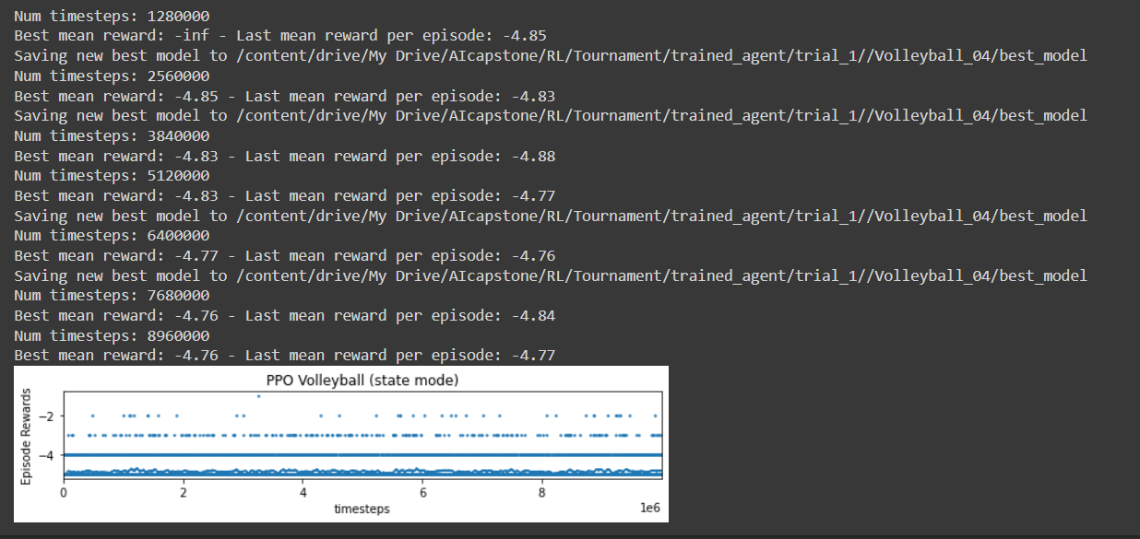

Trial 2:

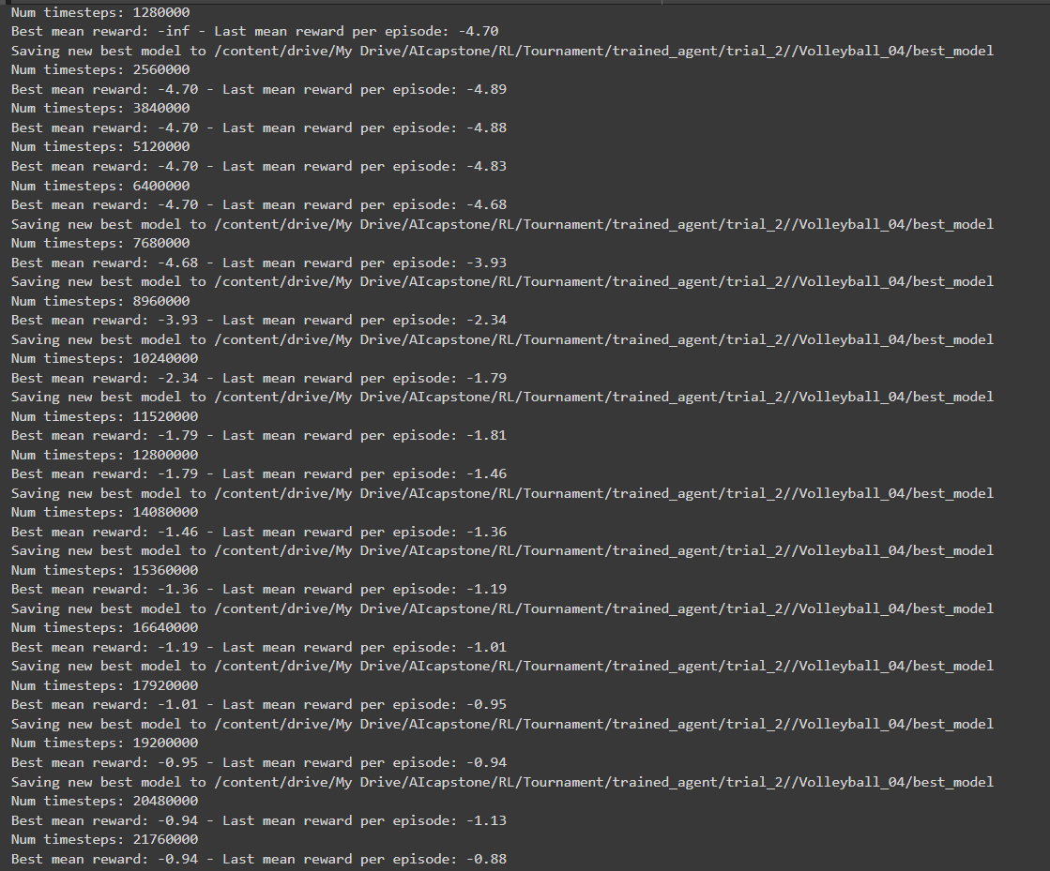

Trial 3:

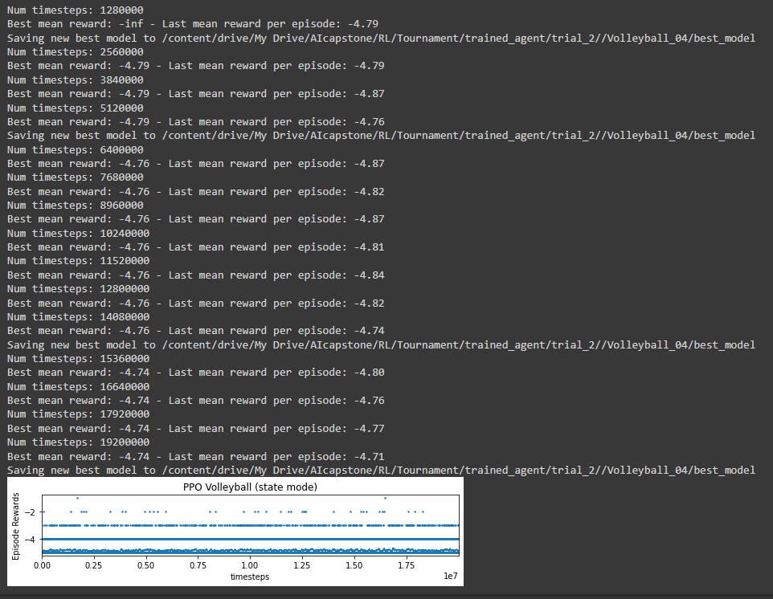

Trial 4:

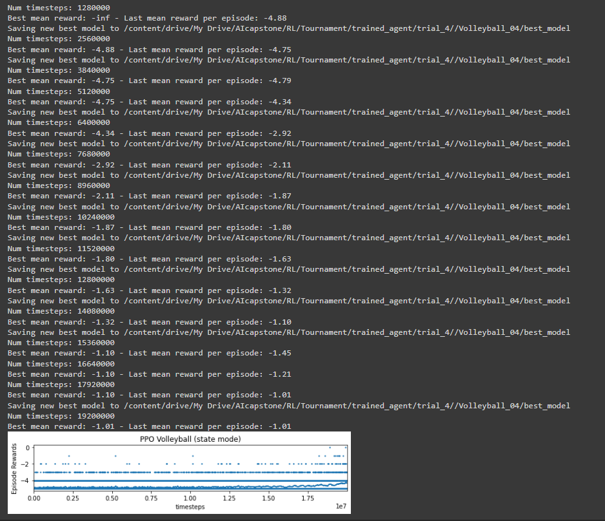

Trial 5:

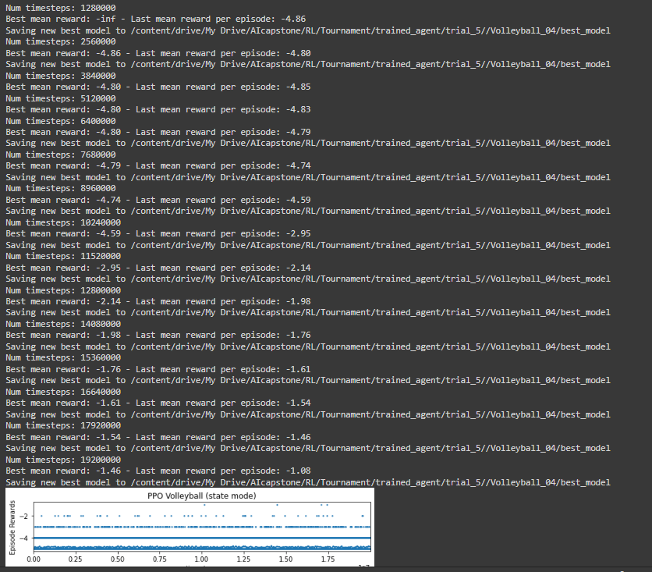

Trial 6:

